LIFE CYCLE TESTING OF ELECTRICAL LOADS BY DOWN COUNTER

ABSTRACT
A desired number is entered through a keypad interfaced to a microcontroller of PIC family. Upon activation, the system counts down one in each second till the set number reaches zero. A relay switches the load ON & OFF for every count thus testing the life cycle of the product.
The working life of many products such as lamps depends on the number of ON/OFF cycles it encounters. This project is designed to be used in industries for testing the life cycle of such electrical loads (lamps, motors etc) using a down counter.
This proposed system uses microcontroller of 8051 family with a keypad interfaced to it to enter a required number. 7-segment displays are used for displaying the number /count. Once the circuit is powered, the counter is set using the keypad to count down anywhere from 999 to 0. The counter starts decrementing from the set number to 0 per each count and simultaneously making the load (i.e. bulb in this circuit) turn ON and OFF by a relay. Reaching the zero count it finally remains OFF.
The project can be further enhanced by using mono stable triggering device to stop the counter in the event of failure of the load before reaching the zero. Thus the exact life cycle of the load can be estimated.

BLOCK DIAGRAM
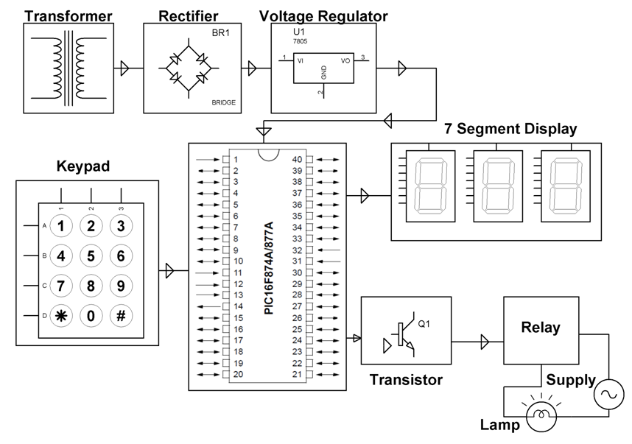

HARDWARE REQUIREMENTS:
PIC series Microcontroller, Keypad, 7 Segment Displays, Lamp, Transformer, Voltage Regulator, Diodes, Relay, Transistor, Crystal, Resistors, Capacitors, LED, Switch.
SOFTWARE REQUIREMENTS:
HI-TECH PICC Tool suite
Language: Embedded C or Assembly.

